BLINKIT Analysis
1. Total Sales
SELECT CAST(SUM(sales)/1000000 AS DECIMAL (10,2)) AS Total_sales
FROM Blinkit
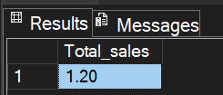
2. Average Sales
SELECT CAST(AVG(sales) AS INT) AS Avg_Sales
FROM Blinkit
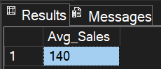

3. Total Sales
SELECT
CAST(SUM(sales)/1000000 AS DECIMAL (10,2)) AS total_sales_in_Mils
FROM Blinkit
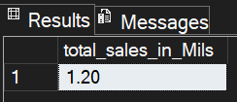

4. Number of Items And Sales
SELECT item_fat_content,
COUNT(item_fat_content) AS count,
CAST(SUM(sales)/1000000 AS DECIMAL (10,2)) AS total_sales_in_Mils,
ROUND(AVG(rating),2) AS avg_rating
FROM Blinkit
GROUP BY item_fat_content
ORDER BY COUNT(item_fat_content) DESC
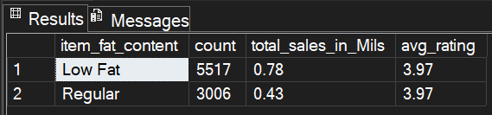
5. Average Rating
SELECT ROUND(AVG(rating),2) AS average_rating
FROM Blinkit
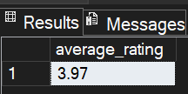
6. Item wise total sales and rating
SELECT item_type,
COUNT(item_fat_content) AS count,
ROUND(SUM(sales),2)AS total_sales_in_Thousands,
ROUND(AVG(rating),2) AS avg_rating
FROM Blinkit
GROUP BY item_type
ORDER BY COUNT(item_type) DESC
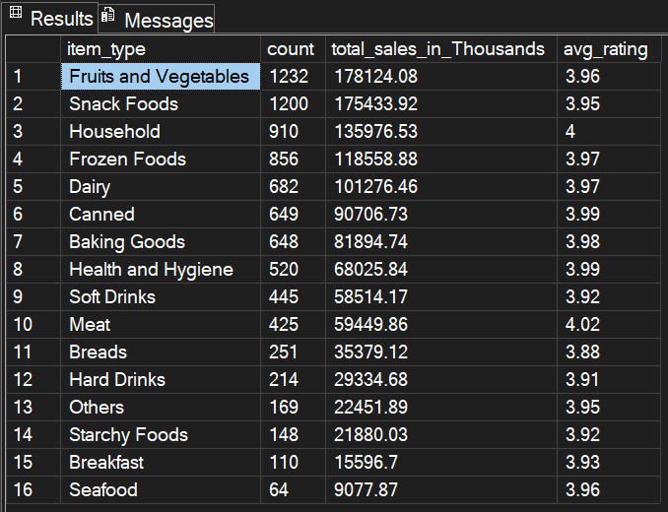
7. Fat Content by Outlet count & Total Sales:
SELECT item_fat_content,
outlet_type,
ROUND(SUM(sales),2) AS total_sales_in_thousands,
ROUND(Avg(sales),2) AS Avg_sales_in_thousands,
COUNT(*) As count,
ROUND(AVG(rating),2) AS avg_rating
FROM Blinkit
GROUP BY item_fat_content, outlet_type
ORDER BY item_fat_content, outlet_type
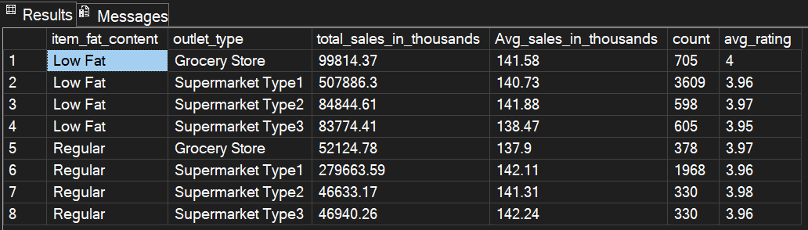
8) Location type analysis
SELECT outlet_location_type,
item_fat_content,
ROUND(SUM(sales),2) AS total_sales_in_thousands,
ROUND(Avg(sales),2) AS Avg_sales_in_thousands,
COUNT(*) As count,
ROUND(AVG(rating),2) AS avg_rating
FROM Blinkit
GROUP BY outlet_location_type, item_fat_content
ORDER BY item_fat_content, Outlet_location_type
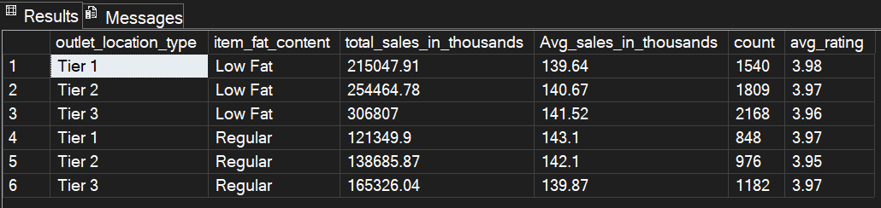
9. Percentage of Sales by outlet size:
SELECT outlet_size,
ROUND(SUM(Sales),2) As outlet_size_sales_in_thousand,
ROUND(100* (SUM(sales)/ (SELECT SUM(sales) FROM Blinkit)),2) as percent_sales
FROM Blinkit
GROUP BY outlet_size
